EX AUTUMN LEAVES
26/27 Sep 26

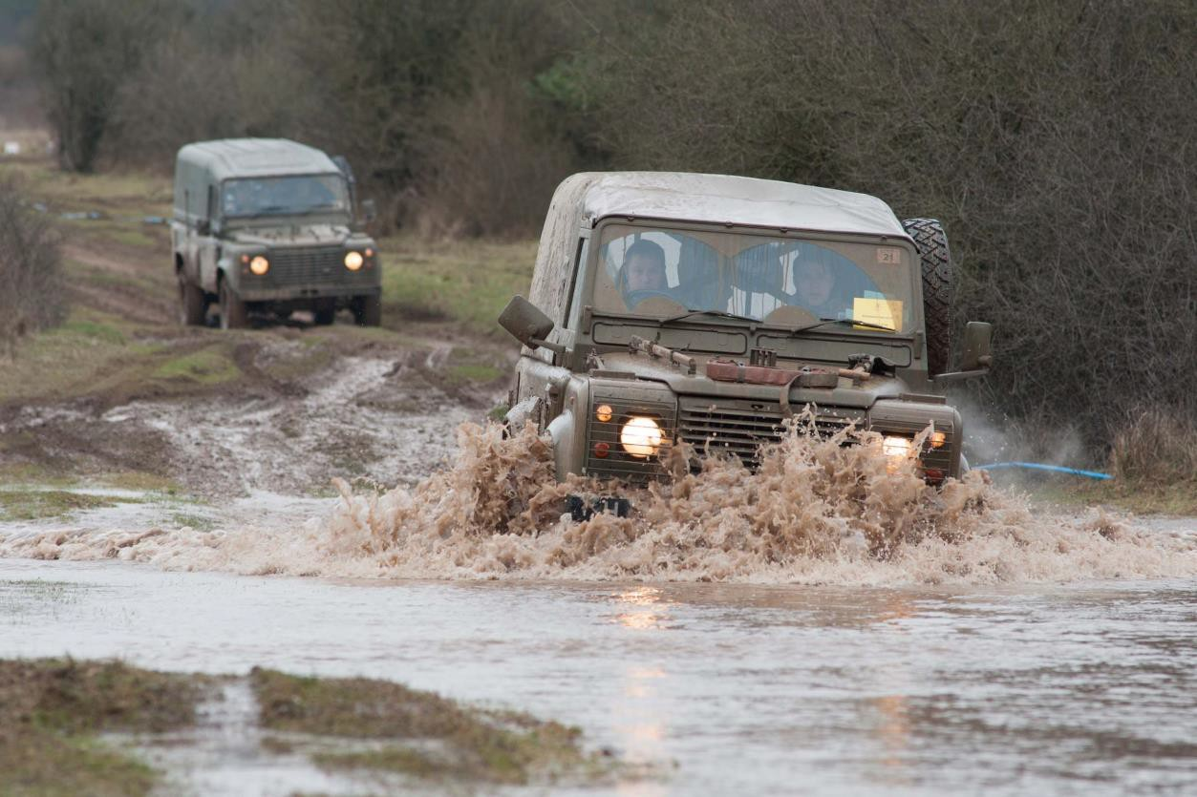

Additional Supplementary Rules

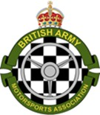

- Background. This event is governed by the Motorsport UK Regulations and all references to regulations in the form (A.1.2.3) are to these regulations. This annex highlights relevant regulations and outlines specific modifications and additions which apply. A general 4x4 Navigation event guide is here.

- All parts of the route have been cleared by Motorsport UK Route Liaison Officers (RLO) and HQ Salisbury Plain Training Area (SPTA) has been consulted during the planning. Concurrent to this event will be a military Safe & Skilled driving/navigation exercise for Service personnel in Service vehicles (incl MAN Support Vehicles). Separate instructions will be issued to Service personnel in the form of an Administrative Instruction. The use of Service vehicles is authorised by 2026DIN10-008-BAMA Navigation Events 2026 and Joint Services Publication (JSP) 800.

Section 1 - Regulations and guidance for competitors

- Eligibility. The event is open to members of the Armed Forces who are members of single service motorsports associations; and members of the clubs and associations listed below. All participants must hold at least a RS Clubman licence (available at https://www.motorsportuk.org/competitors/rs-clubman-licence/ ), or for motorcycles, an Auto Cycle Union (ACU) for a minimum of Trials competitions.

  - BAMA
  - RNRMMSA and RAFMSA
  - Hants and Berks ROC
  - Association of Land Rover Clubs
  - CSMA Club
  - Devizes and District MC.
  - Craven MC.
  - Dorset LR Club
  - Salisbury and Shaftsbury car Club
  - Cheltenham and Cotswold ROC
  - Midland ROC
  - Yorkshire off-road Club
  - Any other club which applies for an invitation, subject to Motorsport UK rules (D 4.3.1).

- Entries. The maximum number of entries will be 60 however five reserves will be allowed and given places if any other entry fails, either to turn up or to meet entry conditions. The entry list opens on publication of these regulations and closes at 1130hrs on 24 Sep 26. Entries will only be accepted via a completed online entry form. Entries will only be accepted via a completed online entry form (to follow on the BAMA website) or request one from autumnleaves4x4@gmail.com
- Teams. Multiple entries to form teams are welcome.
- Classes and seeding. Entries will be seeded by the Event Secretary. Entrants with experience of civilian navigation events will be classified by the event organiser and the decision will not be subject to protest. Crews will be classed as follows:

  - Expert. Where either crew member has competed in 6 or more BAMA navigation events.
  - Novice. Where either crew member has competed in 2 or more but less than 6 BAMA navigation events.
  - Beginner. Where neither crew member has competed in more than 2 BAMA navigation events

- Fees. Entry fees are to be paid by BACS before the event and proof of payment retained. Late entries are permitted to pay cash on the day of the event by prior agreement. The entry fees per crew, are as follows:

  - Green Fleet (Military) vehicles £35.
  - Private Vehicles – Non-BAMA members £110 (includes Road Section Insurance Cover @ £65).
  - Private Vehicles – BAMA Members £100 (includes Road Section Insurance Cover @ £65).
  - Motorcycles – £45 (Includes Road Section Insurance Cover @ £16).
All payments are due to ASCB Central Bank, Sort code: 16-19-26
Ac No: 10529980
Reference: AL26 Abbreviated Unit Name or Driver Surname & Initial. (e.g.,
AL26/154RLC or AL26/SMITH J).

- Documentation. The following documents will be checked at signing on:

  - Current driving licence or electronic printout from DVLA for any crew member intending to drive.
  - RS Clubman licence (Both crew members).
  - ACU Licence (Trials or higher) for motorcyclists.
  - My Drive, formerly FMT600 (military drivers in Green Fleet only).
  - MoD Form 90 (service ID card, military personnel only).
  - FMT 1001(ATUD) endorsed ‘Ex Autumn Leaves’ and signed by the MTO (military vehicles only). POT code is 17b.
  - Copy of Unit Part One Orders confirming authority to participate (military crews only).
  - An in-date club membership card.
  - Current certificate of insurance (civilian vehicles only).
  - Current certificate of a DfT test (civilian vehicles only).
  - CO/HoE Authority to participate using Green Fleet (MOD Civil Servants only).
- Road Section Insurance (Privately Owned Vehicles). Competitors must ensure they have suitable insurance for travel to and from the Event and for participation in it. Motorsport UK’s Master Public Liability policy provides third-party cover for activities under the Event Permit, but does not cover Road Traffic Act liabilities. An optional Motorsport UK-administered third-party “top-up” insurance policy is available for this Event, providing Road Traffic Act liability cover for sections on public highways. It supplements, but does not replace, your own motor insurance. The acceptance criteria for this scheme are as follows:

- Drivers must be aged 19 years or older.
- Drivers must be UK residents for over 1 year, and have held a Full UK Car Licence for at least 6 months.
- Drivers must have not been banned from driving in the last 5 years, and no criminal convictions.
- Drivers must have no more than 6 penalty points on their licence and/or no more than 1 fault motor claim in the last 3 years in their history
- Drivers must be a named driver on a valid motor insurance policy for the vehicle they are driving.
- Drivers must not already have the 3rd Party Extension (top-up) for Road Sections cover already on their existing motor policy
- Vehicles must have a valid MOT and taxed for the road (unless exempt from doing so).
- Vehicles must be road going/road legal and have a UK Registration Plate assigned and attached.
- Vehicles must be in the custody or control of the competitor and be participating in a motorsport event permitted by the Policyholder (Motorsport UK Association Ltd).
(1) Competitors who do not comply with any of the above criteria must contact Kingfisher Motorsport at motorsportuk@kingfishermotorsport.com as early as practically possible in advance of the event to discuss their application to confirm whether cover can still be offered and whether there are any additional terms.

(2) All Competitors will be required to sign a declaration before the Event to confirm that they either have adequate insurance cover for the Event or need cover under the Motorsport UK top-up policy. If they do not meet the minimum eligibility criteria, they must have referred themselves to and been approved by Kingfisher before the start of the Event.

(3) Those Competitors who do require cover under the Motorsport UK top-up policy will be required to pay the organiser’s an additional fee of £65 to cover the Motorsport UK permit surcharge.

- Dress. Military personnel competing in service vehicles are expected to wear uniform. However, single service Motorsport branded clothing with MTP trousers is permitted with BAMA branded clothing.

- Event timings. Timings are per the following table and will be ‘GPS’ time and as displayed on smart watches and smart phones.
Serial | Time | Location | Event | Comments
1 | 1200 – 1400 |  | Registration & scrutineering | All
2 | 1300 – 1500 |  | Training and plotting | Beginners
3 | 1430 | Classroom | Marshals briefing
4 | 1500 | Theatre | Safety briefing | Mandatory - all
5 | 1530 – 1700 |  | Daylight practical exercise
6 | 1800 |  | Car 0 on course | Succeeding vehicles will start at 1-minute intervals.
7 | 0200 |  | Prize giving

- Location. Event HQ: Rollestone Trg Camp, Salisbury Plain Training Area, SU 096 451.

- Personal equipment. All crews are advised to carry the following equipment:

  - Pens
  - 2B pencils and rubbers
  - Hi-lighter pens
  - Tracing paper or acetate
  - Illuminated map magnifier
  - Roamer (or method of accurately plotting grid references)
  - Head torch.
  - A map board

- Maps. OS 1:50,000 sheets 173,174,184 are required for the event. The committee recommends custom maps centered on Northings 37-60; Eastings 99-24 from the OS website which saves cost. Maps will be spot checked during the event. The Military SPTA map, GSGS 6500, does not cover the whole event.

- Accommodation. No accommodation is available via the event organisers. Service personnel requiring accommodation should contact Tidworth/Bulford/Larkhill/Warminster Garrisons via CABS; email DIORDPFI- PACSLAMISTeamGpMail@mod.gov.uk.

- Food. The Junior Ranks Dining facility (JRD) in Larkhill Garrison will be available for use by Service personnel on a pay as you dine basis. Civilian outlets are available on The Packway in Larkhill.

Section 2 - Rules and guidance for vehicles

- Competing Vehicles. These vehicles must have four wheels and two side by side forward facing front seats. Vehicles are to be essentially standard, and no special vehicles are permitted. What is a special will be decided by the organisers but will include fire engines and ambulances. Whilst modified vehicles are permitted it must be accepted that, to retain the navigation trademark of the event, offroad racers and similar vehicles are discouraged unless fully ‘Road Legal’. If in doubt, please consult the Event Secretary before entering. The maximum size of vehicle should be about the size of a long wheelbase Land Rover. Crews are required to use seat belts and always be in forward-facing seats when competing.
- DfT (MOT). All vehicles must have a valid DfT test (MOT) where required by law. All vehicles must be roadworthy.

- Vehicle equipment. Vehicles must carry the following equipment which will be inspected at scrutineering and spot checked throughout the event.

  - Warning Triangle.
  - First Aid Kit
  - Tow Rope/strop, this must be non-kinetic. Additional ropes, of any type, may be carried. Winches may be used with care if necessary.
  - D Shackle (Optional for GF Vehs.). (stamped with the SWL appropriate for weight of the vehicle,). This can be a ‘JATE’ ring.
  - Fire Extinguisher, at least 1Kg.
  - A reflective waistcoat or jacket per crew member.
  - A small spill kit. These are available online http://www.yellowshield.co.uk or at local auto factors. (NSN 7920-99-000-6673 for green fleet).
  - A rubbish bag of at least 25 litre capacity.

- Fuel. The route is approximately 100 miles; vehicles should be capable of travelling that distance without refuelling. There are many garages in the area, the nearest being at Durrington or at the Princess roundabout/Solstice Park on the A303. Those with ERIC keys can use Larkhill Garrison at SU 1269 4487 It is not possible to sign out an ERIC key at Larkhill Garrison therefore GF crews must draw one at their own unit or bring an Agency Fuel card.

- Scrutineering. On arrival, proceed to scrutineering at SU 096 451. Event HQ is within Rollestone Trg Camp – proceed by foot from the car park. Vehicles will comply with the technical regulations. Vehicles not fitted with hard tops must have suitable roll over protection e.g., soft tops must be fitted with a suitable roll bar. Whilst it is appreciated that suitable tyres are sensible, aggressive tyres are totally unnecessary on the route. The route has been traversed quite safely using all terrain tyres and if you are unsure, please contact the Event Secretary before entering. Green Fleet vehicles are to be fitted with the tyres shown in the CES. The chief scrutineer will advise the Event Secretary whether a vehicle may start or not. The decision of the Event Secretary is final and not subject to protest. Vehicles and motorcycles should be checked in advance by competitors or their repair agents using the check sheet at the following link.

Section 3 – Rules and guidance for event conduct

- Identification. R 6.1 Competing vehicles will be identified by small numbers to be placed in the lower nearside wind screen and lower near side rear screen (if fitted). These numbers are to be removed at the end of the event.

- Service Crews. Service crews are not permitted. Outside assistance is an offence.

- Electronic devices. The following items are not permitted and risk disqualification.

  - Radio transmitters/receivers other than receiving public broadcasts.
  - Satellite derived position indicating devices.
  - Distance measuring device, other than that fitted as standard.
  - Speed calculating device other than that fitted as standard.
  - Mobile phones except for emergency use.
  - Computer or electronic based map systems.
  - Auxiliary LED light bars.
- Speed. All competitive sections have been set for an average speed of 25 MPH/40 KPH. Posted speed limits must be observed (the speed limit on SPTA is 30 mph, even where not posted) and driving standards marshals using ‘speed guns’ will be in operation throughout the event. See paragraph 16.

- Quiet Zones (QZ). These will be made known to competitors prior to starting. Speed must be reduced in QZ. All auxiliary lighting must be extinguished, as high a gear as possible must be selected and progress must be gentle within QZ. Driving standards
marshals will monitor compliance. All posted speed limits of 30 mph or less, on public highways are deemed to be QZ. The posted speed limit will apply in QZ on Class A&B roads. Some villages have 20mph zones!

- Stop. Junctions where a stop is mandated will be made known to competitors prior to starting. At a STOP junction all wheels must cease to rotate and vehicular velocity must be nil, prior to reaching the stop line. Driving standards marshals will monitor compliance. These are in addition to posted stop junctions for which the same rules apply. All give way junctions are deemed to be STOP junctions for this event.

- Controls. These will be as R 11.1-11.6.3.

- Sections. These will be in accordance with R10.1 et seq.

- Route. Some pre-plot information such as quiet zones (QZ) and stop junctions could be issued electronically as part of the Final Instructions (FI). Further information relating to QZ etc could be included in the route instructions. The route will be entirely on public vehicular rights of way. Surfaces will vary from mud to Class A roads. Route instructions, in the form of a roadbook, will be issued as shown in paragraph 7b (5), Route instructions could be in any, or all, of the following forms, or a combination thereof:

  - Aerial imagery of various scales.
  - Marked photocopy maps of various types and scales.
  - Tulip diagrams.
  - Map tiles.
  - Strings of numbers. This will include grid references, spot heights and grid line crossing.
  - Trace.
  - Map symbols.

- Competitive sections. In the competitive sections some additional regulations apply.

  - Timing. Time will be as defined in R12.1 et seq except that 12.8.2, 12.9 and
12.9.3 do not apply.

  - At all controls you will be booked in when you present your timecard to the marshal; you may ask for a later time than shown on the marshal’s clock but not an earlier time. All controls are QZ for 100mtr radius of the control.

  - Main time controls (MTC). To qualify as finishers crews/riders must visit all MTC within their maximum lateness, which is 30 minutes at MTC. Time will be given when the timecard is presented to the marshal. Lateness incurred at the half-way halt will not be carried forward to the second half for OTL. So, if you incur 25 minutes lateness at the half-way MTC you will start the second half with no
lateness. However, any lateness incurred in either or both sessions will be penalised. A 100m warning board will be posted.

  - Time controls (TC). These are manned controls where a time of visit will be given. To avoid penalty, crews/riders must visit TC in the order given in the route instructions. Maximum lateness at a TC is 15 minutes. So, if a crew/rider gets to a TC and it is open, they’ll be given the time on the marshal’s clock and incur penalties if late. If the control is closed when they get there, they will be deemed not to have visited the control and be penalised accordingly. Lateness incurred at a TC will NOT go towards accumulated maximum lateness, this only applies at MTC. Time will be given when the timecard is presented to the marshal. A 100m warning board will be posted.

  - Route Checks (RC). Route checks in the form of letter boards will be posted to monitor compliance with route instructions. The code letter/s/number/s are to be entered in the next available space on the timecard.

  - Manned secret Controls (MSC). These will be in undisclosed locations to monitor driving standards which includes speed, stop and QZ compliance; also route compliance. No warning board will be posted. Competitors must stop at the control and comply with the marshal’s instructions.

  - Timecards. Completed timecards will be collected at the Rest Halt MTC and at the final MTC.

  - Break. There will be compulsory halts during the night phase. They will be on byways and without any facilities; crews are to be self-sufficient. Breaks will be on a byway and without any facilities; crews are to be self-sufficient.
  - Lateness. Maximum lateness at TC will be as shown above. However, a crew late at one TC can be the same amount late at subsequent controls without incurring further penalty. Time may be made up provided that the distance between time controls is more than 2.5 miles and that the distance is not traversed in less than ¾ of the time allowed. (R12.7).

- Penalties. Specific additional and modified penalties are applied and are as follows.

Description of offence | Resulting action | Comments
Excessive noise, driving or behaving in a manner which is deemed detrimental to the good reputation of the sport. | Disqualification
Deliberately driving off public rights of way, unless directed by an official or the roadbook. | Disqualification
Excessive damage to a vehicle. | Disqualification
Receiving outside assistance. | Disqualification
Breach of regulations as defined. | Disqualification
Entering an out of bounds area. | Disqualification

Not complying with an instruction for  which no penalty is specified, provided that a warning is given. | 10-point penalty | As judged by any official.
Drivers. Only the driver nominated on the entry form may drive on competitive sections. Any other person who drives on public roads must hold a licence. | Disqualification | As judged by any official.
Booking in late at a time control (MTC/TC) | 1 point per minute
Booking in early at a time control (MTC/TC) | 2 points per minute
Not providing proof of visiting a manned control | 15-point penalty
Failing to record a RC | 1 point per check
Wrong direction of approach (DOA) or  direction of departure (DOD) to/from a manned control | 1 point per offence | Where DOA/DOD is known.
Speeding - 1st offence | 10-point penalty
Speeding - Subsequent offences | Disqualification
Infringement of QZ regulations - 1st offence | 10-point penalty
Infringement of QZ regulations - 2nd offence | Disqualification
Ineffective silencer | Disqualification
Minor traffic offence involving a 3rd party | 1st offence- 10-point penalty  2nd offence- Disqualification
Illegible or altered entry on a timecard (per offence) | 10-point penalty
Not complying with a requirement of the roadbook (per offence) | 10-point penalty
Not wearing a seat belt in a moving vehicle | Disqualification

- Results. Provisional results will be in accordance with 13, 5, 6.1 et seq. They will be declared final, subject to there being no protests, 30 minutes later. Printed results sheets will not be available to individuals. Results will be posted to crews via digital means as soon as practicable following the completion of the event. The organisers reserve the right to delete the results of sections from the results at their discretion. Should this arise, the reason will be made known to competitors. (See paragraph 24 and 32 for penalties.) The crew gaining the least number of points will be declared the winner. In the event of a tie ‘furthest cleanest’ will apply. In the event of a tie between teams the team with the highest placed individual crew will be declared the winner.

- Prizes. Prizes are subject to change by the organisers without competitor consultation. The prizes are provisionally as follows.

Serial | Description | Comments
1 | 1st 4X4 Car | Two awards.
2 | 1st Truck | Two awards.
3 | 1st Motorcycle | One award.
4 | Spirit of the event | One award.

- Final Instructions. Final Instructions, will be e-mailed and may include Pre-plot information. Queries relating to the event should be addressed to the Event Secretary autumnleaves4x4@gmail.com. A full list officials will be detailed in Final Regulations.

