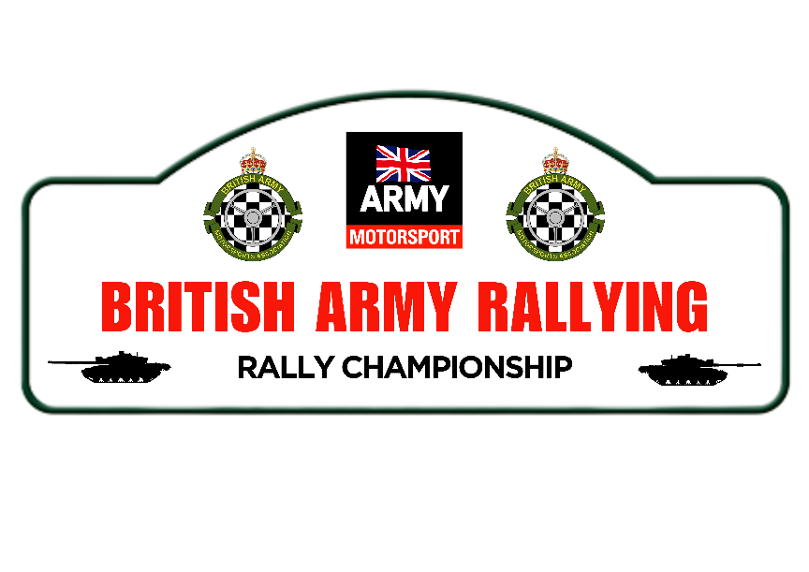

2024 ARMY RALLY CHAMPIONSHIP - REGISTRATION FORM

PERSONAL DETAILS:

NO, RANK (If applicable) / NAME and CORPS
BAMA MEMBERSHIP No
(To be eligible for awards)
MSUK License Type & No
ADDRESS (inc Regiment)
Service
ADDRESS
Home
E-MAIL ADDRESS
WORK PHONE No
MOBILE PHONE No

VEHICLE DETAILS:

MAKE / MODEL
COLOUR
ENGINE SIZE

CLASS

Please indicate in the appropriate space below the event you wish to nominate for each round of the Championship. Please ensure you read the Championship regs carefully (para 7.9) and return an event result within 14 days of the event.

ARMY RALLY CHAMPIONSHIP EVENTS
 | Dates | Event  (List which event you will be competing in)
Round 1 | Any event held between 1 Jan and 30 Jun
Round 2 | Any event held between 1 Mar and 31 Aug
Round 3 | Any event held between 1 May and 31 Oct
Round 4 | Any event held between 1 Jul and 31 Dec
Round 5 | Coningham Cup | Round 5 is a mandatory event. It must be attended by all personnel that are available. No crew will be able to score points at an alternate event that clashes with the Organisers nominated Round 5 (unless in receipt of express permission by the Organiser).

Email Return to: jonathan.quintrell579@mod.gov.uk and Benjamin.De-Ronde654@mod.gov.uk

