One month and 100 miles further south, the RAFMSA Race Challenge reaches Oulton Park in Cheshire for Round 5. After the very hot weekend at Anglesey, the prospect of rain during race day was somewhere around 90 percent, so as practice approached a keen eye was keep on the sky. Ed Fuller was hedging his bets with dry tyres on the front and wets on the rear, quicker to change just one end.

Even though the Race Challenge is not technically a championship a table of performance is produced. Bragging rights go to Billy Fletcher, followed by a very surprised Cpl Chris Camp. Chris is also leading the Army Challenge. Billy was going to have a very difficult weekend as he had been suffering all week from a virus.
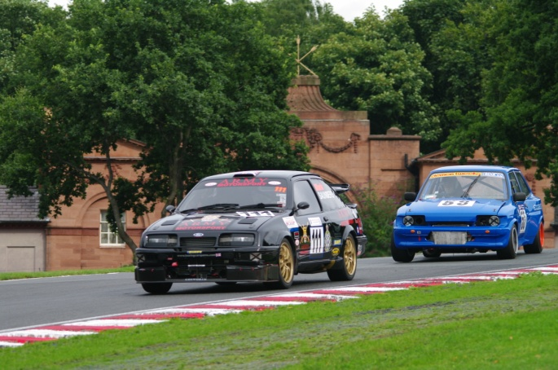
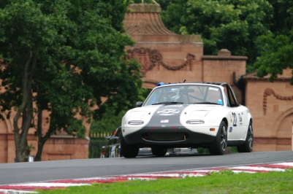
This round of the championship was back to being Tri-service again with the return of
Lt Cdr Richard Scott (Royal Navy) and WO Mark Saunders (Army), Mark's absence at previous round being caused by his attendance of a 'Knife Fork and Spoon' course. Well done Captain Saunders. Also returning as a guest driver, was Mr Ian Smythe, International racing driver who has previously raced at Classic Le Mans, as his race-ware testifies and so will he, if you ask him. Newcomer for this round was Daniel Murphy driving a nicely prepared Evo IV. Unfortunately despite a last minute dash to 'Emerald M3D Limited' in Norfolk Richard Green was unable to cure a misfiring engine in his Westfield. Between Scrutineering and the paddock John Walton's STM Locoblade ran out of electricity, a problem easily solved by a trip to the track side Race Shop and the extraction of £100 from John's bank account.
Richard Scott's Mazda MX-5
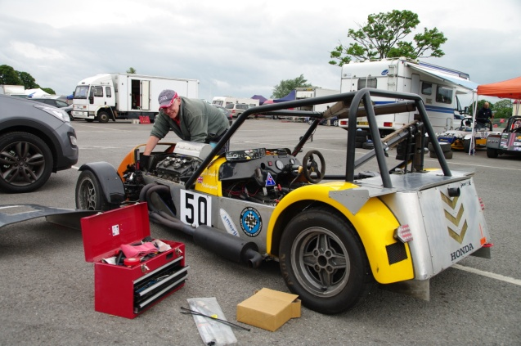
Practice proved to be a bit of a bit of an
eye-opener for some of the drivers who had not raced at Oulton Park before. Flt Sgt John Davies was not happy in the normally good handling Tiger Super Six and reported that it was very nervous and didn't like the rough undulating track. Have sorted the suspension on the Golf, Sqn Ldr Darren ‘Howie’ Howe was now able to drive through the corners rather than fight the car to get round them. John Walton in the STM Locoblade was suffering with gear selection problems.
Mark and Ian - Cosworth Power

The electrical gremlins were certainly at work. After only a few laps the alternator belt failed on Mark Saunders Sierra Cosworth forcing him in to the pits. Sgt Raz Nutley in the Peugeot 206 returned to the pits with a car running on three cylinders, finally traced to a broken fuel injector plug, which was easily fixed. Daniel Murphy in the Evo IV suffered a spin at Lodge corner when a sensor broke causing a momentary loss of power to the affected wheel.
John Walton effecting repairs
At the end of practice Ian Smythe's Fiesta Cosworth stopped in parc ferme after the failure of the High Pressure fuel pump, another trip to the Race Shop, another £100 (Do you see a pattern here) and he was ready for the first race.

Despite his problems Ian was only bested by Sqn Ldr Darren Berris in the very rapid V8 Westfield. Darren's practice wasn't without incident as the car still has problems with a high speed vibration and noisy rear axle.
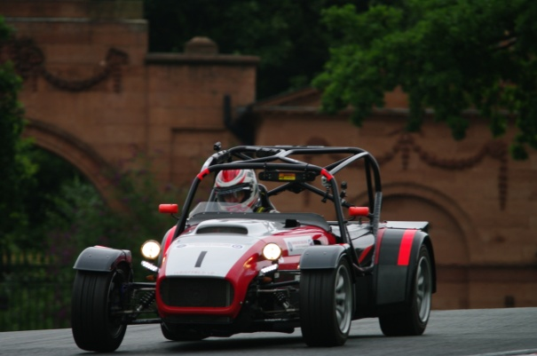
The weather remained dry so with minutes to go before the race everyone went with dry set-up and tyres. At the start Darren in the Westfield again had problems getting the V8 away from the line, and by the first corner Ian and Ed managed to sneak past, with Billy, Howie and John Davies following. Trevor's race in the other 206 was to be short lived as having run over a curb, the exhaust became detached and he could not continue. John Walton's gear selection problems continued, at the start he selected first, but the car thought second would be a better idea so instead of racing away past Raz, he dawdled off the being passed by the remainder of the grid.
Darren Berris through Lodge corner

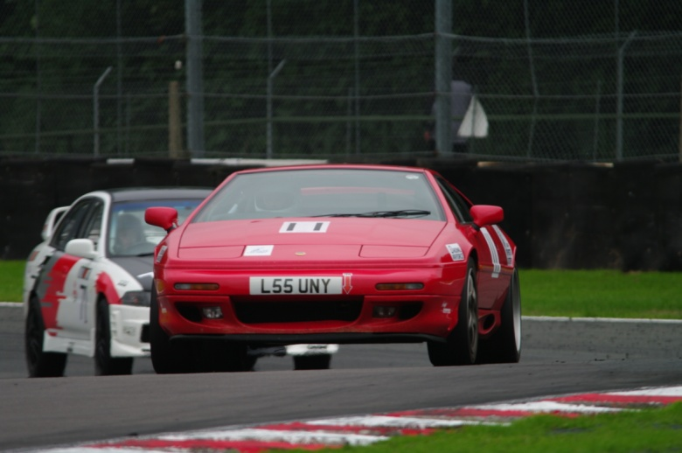
It wasn't long before Darren in the Westfield regained the lead and set off at a blistering pace which no one else could match. At the back the newbies Dom in the Lotus and Daniel in the Evo IV were having their own battle. By lap 5 John in the STM Locoblade was down to one gear, so had to retire. The race continued with, Darren in the lead, Ian, Ed and Billy following with Howie circulating on his own, just ahead of John Davies and Raz. As said in other reports, the RAF Race Challenge is not about first past the flag. After all the post race calculations, John Davies had achieved the best Performance Index, so gets the laurels and
No. 1 hat.

Dom finally gets the better of Daniel

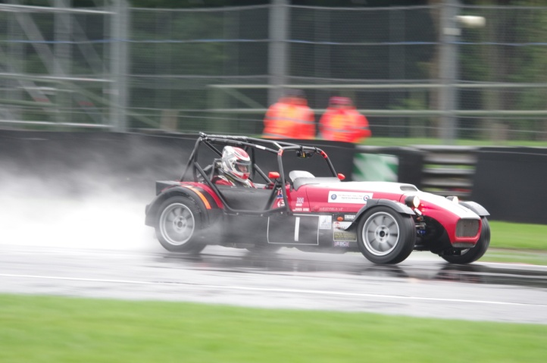
Race 2 for most of the competitors was to be a 100 km team race but due to lack of time and entrants the organizers decided to use the RAF format and hold a 30 minute BARC NM Pursuit race. Once Darren had completed the RAMSA race he had to do a quick change, grab the laptop and rush off to race control to compile the grid handicaps. The pursuit race was to be the last race of the day and unfortunately the weather was against it. All day it had been threatening to rain and as the cars assembled in the Assembly Area the heavens opened and there was one torrential rain storm. Some cars race for cover, others to the pit for wet weather tyres, but Chris and Dom waited as they have just one set of black and rounds. Billy dug around the motor home and got his ancient wet tyres out, ‘Well we don’t racing in the rain much’.
After the warm up lap the cars returned to the pit lane for the staggered start. Thanks must go to John and Raz who weren’t racing and volunteered to stand in the pouring rain to start the race. Once released Darren in the Westfield was again the fasted on track some 16 seconds faster than anyone else.
Rain, what rain?
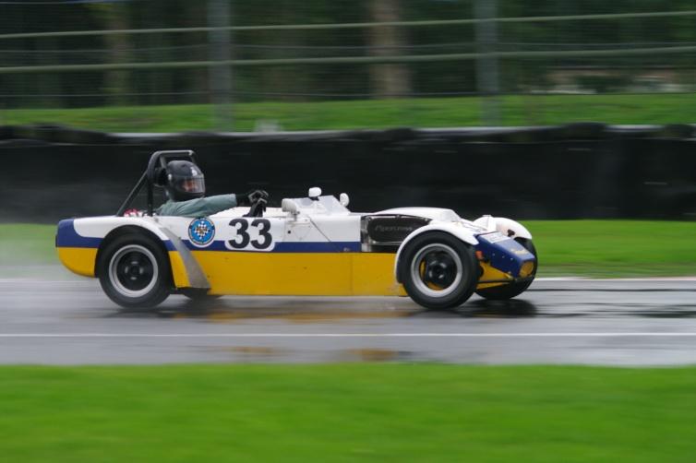
The commentators we fascinated as to what the outcome could be, would it be possible for Darren to make up that much time. The handicaps hand been calculated on dry times so it was very much a lottery as to what would happen. For a long time Chris Camp held the lead in his Lexus putting in consistent times lap after lap, only being caught by Myles Baker’s Ford Fiesta ST two laps from the end and Darren’s Westfield on the last corner before the finish. With Darren’s pace and one more lap and he would probably have won.
Those drivers who finished completed either 18 or 19 laps so despite the rain the handicap calculations were spot on. Darren finished second, Chris third, Billy fifth, with Ed seventh and Dom eighth.

There is only one round of the race challenge left and that will take place at Brands Hatch on Sunday 15th September.

Not only is it the last round of the challenge, but also peoples last chance to impress before the selection of the RAF team for the Birkett six hour endurance race held at Silverstone in October. This year it’s hoped that the Army and maybe the Royal Navy will be entering teams.
Billy on his wooden wet weather tyres

